**Cloud Computing:**

Before Cloud Computing, it was very difficult for start-ups. All the innovation we see in the world is in large part because of Cloud Computing. It made so cheap and easy to experiment in the ways that was possible before and lot more activity in the technology space.

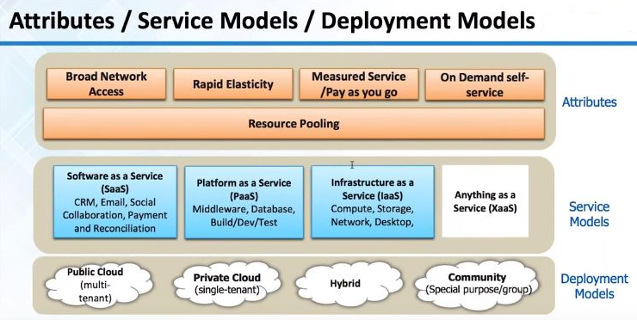

**Attributes:** Key characteristics of cloud computing

* **Broad Network Access**:

We can essentially connect to infrastructure elements from any type of client. It is readily available on Internet.

* **Rapid Elasticity:**

Key characteristic, Stretchable

* **Measured Service:**

It is charged on hourly based or per GB on monthly based.

**Service Models:**

* **SAAS:**

It is for end users and they use only software.

* **PAAS:**

It is a service for developers. Platforms make it very easy to deploy the application and they hide the entire complexity infrastructure from us. It is one layer below Saas.

* **IAAS:**

It is a Raw Infrastructure. A server with 1GB Ram or storage with 1TB can request on hourly bases or on monthly bases.

Most Saas offerings will be probably using a Paas or an Iaas.

In software, if we have an application we can deploy it on infrastructure as a service like AWS. So then our offering become like Saas. They do rather depend on each other. Saas can run on Iaas or Paas. Paas offering can run on Infrastructure as a service.

**Deployment Models:**

* **Public cloud(Multi-tenant):**

Originally Cloud computing was public cloud. It is available on the Internet and Infrastructure shared across many companies and developers. If we are running an application most lightly, hardware shared with other developers or companies in a virtualized manner.

* **Private cloud(Single-tenant):**

Cloud computing industry is maturing right and they are trying to go and make larger companies like Financial, Health care companies as customers. Based on the demand in these industries there is a concept of Private cloud. Where essentially a single-tenant, the infrastructure is only for one company so there is no chance of data, being stole or leaked but we still have cloud characteristics like Elasticity, pay as you go.

* **Hybrid:**

In some cases, there is a possibility of hybrid. Let me take an example: If we are a bank, our core systems like accounting and code banking system, lot of sensitive information, credit scores, day-to-day payment information those has to be secured and these can remain in private cloud. However, certain other applications like learning management system, internet data and public website those can be in public cloud. Therefore, there are some systems and software is which can make it possible for us to see cloud in hybrid fashion.

**Amazon Web services (AWS):**

* Amazon Web Services (AWS) is a collection of remote computing services also called web services that make up a cloud-computing platform.
* These services are operated from 11 geographical regions across the world and operated using zones and edge locations.

**Overview of AWS Products:**

Compute, Storage, Database, Application services, Deployment and Management, Networking.

**AWS Free Tier:**

1 year free tier with all services.

Physical resources like processor memory shared. Virtualization was the original big innovation in the infrastructure side because it allowed sharing our hardware across multiple application or multiple operating systems. AWS works in a similar way that is why AWS is cheap because we do share infrastructure across many companies and developers. In AWS, it is possible to have infrastructure that which is dedicated to our computer.

**Elastic and pay per use Infrastructure:**

Blue line is the traditional hardware. Normally we over estimate what we need, we spend too much upfront. As the application sees some growth, we again have jump in investment like stepladder. However, sometime if we are slow to procure usage may go up faster than the capacity rate. Quality of service suffers i.e. pink shaded patch.

If we see AWS it follows the actual demand very closely because of Elasticity feature we can start servers, change the size of servers at the click of button. It is possible to save a lot of money.

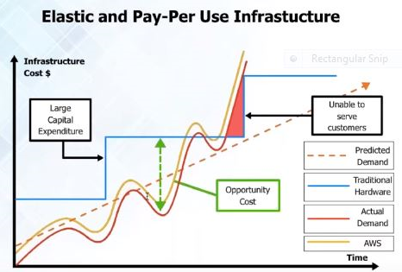

**Regions, Zones and Edge locations:**

* AWS has lot of Regions, Zones and Edge locations.
* AWS is essentially an isolated set of Infrastructure. There is no connection between one region and other. Within a region, there are availability zones that are isolated pieces of infrastructure.
* Edge locations, which are for, content Delivery. For example: If we have YouTube like application where we need to deliver heavy media video, audio images then we need edge locations. Depending on where the user is the closest edge location used to send information to the user.
* Primary Infrastructure is for Regions and Zones.

**Difference between Open stack and AWS:**

Open stack is an open source cloud-computing platform especially it is the software layer. It is a platform that allows creating own infrastructure. Whereas, AWS is not cloud management platform but it is also underlying infrastructure.

Open stack does not give the server capacity or Database capacity, Storage, Networking. With open stack if we have our own server or own datacenter we can create cloud like capabilities with open stack. Especially, good for creating Private cloud. However, AWS is cloud management plus the actual infrastructure.

IBM purchased a company called soft layer, which is also a very good offering.

**Secure:**

AWS has ISO 27000 certification, SAAS 270 certification. We can encrypt data at Rest and secure data over the network. Now AWS has private cloud offerings as well. In Public cloud, Infrastructure shared across customers. However, in Private cloud we can choose that infrastructure used for us.

**Various Offerings from Amazon Web Services (AWS):**

**Compute:**

These things require CPU and RAM i.e. typically virtual type of server offerings.

* **EC2**: Virtual servers in the cloud.
* **EC2 Container Service:** Run and Manage Docker Containers.
* **Elastic Beanstalk**: Run and Manage Webapps.
* **Lambda:** Run code in Response to Events.

**Storage and content Delivery:**

Similar to SAN or NAS and Tape drive from which we can take back up.

* **S3:** Scalable Storage in the cloud.
* **Elastic File System:** Fully Managed File system for EC2.
* **Storage Gateway:** Integrate On-premises IT Environment with cloud storage.
* **Cloud Front:** Global content Delivery Network.
* **Glacier:** Archive Storage in cloud.
* **Import/Export Snowball:** Large-scale data transport.

**Database:**

Offerings whether it is Relational Database or NOSQL Database also things like Data ware house, Cache servers.

* **RDS:** Managed Relational Database Service.
* **ElastiCache:** In-memory cache.
* **Redshift:** Managed petabyte-scale Data ware house services.
* **DynamoDB:** Predictable and scalable NOSQL Data store.
* **DMS:** Managed Database Migration Service.

**Developer Tools:**

* **Code Commit:**  Store code in private GIT Repositories.
* **Code Pipeline:** Release software using Continuous Delivery.
* **Code Deploy:** Automate Code Deployments.

**Networking:**

In this, we have TNS servers, Virtual Private cloud. These are secured isolated cloud resources.

* **VPC:** Isolated Cloud Resources.
* **Direct Connect:** Dedicated Network Connection to AWS.
* **Route53:** Scalable DNS and Domain Name Registration.

**Security and Identity:**

We can create User ID’s control that has to access what.

* **Identity and Access Management:** Manage User Access and Encryption Keys.
* **Inspector:** Analyze Application Security.
* **Directory Service:** Host and Manage Active Directory.
* **WAF:** Filter Malicious Web Traffic.

**Management Tools:**

Stuff for management things like cloud watch which is used to monitor Infrastructure like Storage running out, is the server alive or not.

* **Cloud Watch:** Monitor Resources and Applications.
* **Cloud Trial:** Track User Activity and API Usage.
* **Service Catalog:** Create and use Standardized Products.
* **CONFIG:** Track Resource Inventory and Changes.
* **Cloud Formation:** Create and Manage Resources with Templates.
* **OpsWorks:** Automate Operations with chef.
* **Trusted Advisor:** Optimize Performance and security.

**Analytics:**

In this phase, we have Hadoop offerings so that we can run 50 or 100 nodes by using **EMR** (Elastic Map Reduce).

* **Data pipeline:** For Data-Driven workflows.
* **EMR:** Managed Hadoop Framework.
* **Elastic Search Service:** Run and scale Elastic Search Clusters.
* **Machine Learning:** Build smart Applications quickly and easily.
* **Kinesis:** Work with Real-time Streaming data.

**Mobile Services:**

* **Cognito:** User Identity and Application Data Synchronization.
* **Mobile Analytics:** Collect, View and Export Application Analysis.
* **Mobile Hub:** Build, Test and Monitor Mobile application.
* **Device Farm:** Test Android, Fire OS and ios applications on real devices in the cloud.
* **SNS:** Push Notification Service.

**Internet of Things:**

* **AWS LOT:** Connect devices to the cloud.

**Enterprise Applications:**

* **Workspaces:** Desktops in the cloud.
* **WorkMail:** Secure Email and Calendaring Service.
* **WorkDocs:** Secure Enterprise Storage and Sharing Service.

**Application Services:**

These are Helpers, which can send Email and Notification.

* **App Stream:** Low Latency application streaming.
* **Elastic Transcoder:** Easy-to-use Scalable Media Transcoding.
* **API Gateway:** Build, Deploy and Manage API’s.
* **CloudSearch:** Managed search service.
* **SQS:** Message Queue Service.
* **SES:** Email Sending Service.
* **SWF:** Workflow Service for Coordinating application components.